**TRAVEL AND TOURISM MANAGEMENT SYSTEM**

**ABSTRACT**

The Travel and Tourism Management System is a Java-based desktop application developed using Swing for the graphical user interface and JDBC for database connectivity. This project aims to streamline the operations of a travel agency, offering a convenient interface for customers and administrative users alike. The system enables customers to book hotels and tour packages, manage their profiles, and access all relevant travel information, while allowing administrators to manage packages, hotels, and customer details. With its intuitive interface and efficient backend connectivity, the system enhances the experience of planning and managing travel itineraries.

**PROBLEM STATEMENT**

Traditional travel agencies often face challenges such as inefficient data management, limited accessibility, and high dependency on manual processes. Customers have to visit physically or rely on outdated systems to book hotels or packages. There is a need for an integrated platform where users can interact with the agency digitally, and admins can manage data with ease. This project solves these issues by providing a complete travel management solution in a Java desktop environment.

**USE CASES**

**1. User Registration and Authentication**

- Users can create a new account with their credentials.

- Secure login mechanism validates users using stored credentials in the database.

- Redirects users to their personalized dashboard after successful authentication.

**2. Hotel and Package Browsing and Booking**

- Displays all available hotels and packages fetched from the database.

- Users can select and book desired services with live data entry.

- Bookings are recorded along with user details and transaction time.

**3. Admin Management Panel**

- Admin login via a separate interface.

- Provides access to add/edit/delete hotels and packages.

- Enables viewing all user details and booking information.

**4. Customer Profile and Password Management**

- Users can view and update their profile data.

- Offers a Forgot Password feature for recovery via a secured verification.

**5. Booking History and Management:**

- Customers can view their current and previous bookings.

- Admin can monitor all user bookings for tracking and operational analysis.

**6. Code Overview:**

- Graphical User Interface (Swing):

- Utilizes components such as `JFrame`, `JPanel`, `JButton`, `JLabel`, `JTable`, etc.

- Implements dynamic switching between windows and user flows.

- Panels include `Login`, `Signup`, `CustomerHome`, `AdminHome`, etc.

**7. Database Connectivity using JDBC:**

- `Conn` class handles driver loading, connection creation, and SQL execution.

- CRUD operations for all modules—hotels, users, bookings—are supported.

- Uses `PreparedStatement` to avoid SQL injection and improve query performance.

**8. Authentication System:**

- `Login`, `AdminLogin`, and `ForgotPassword` manage secure access.

- User input is validated against stored database records.

- Role-based redirection ensures separate workflows for admin and users.

**9. Booking Logic and Panels:**

- Classes like `BookHotel` and `BookPackage` handle booking creation.

- Booking details are inserted into respective database tables.

- Confirmation messages are displayed upon successful operation.

**10. Admin Control Features:**

- Admin can manage hotel and package listings through `AddHotel`, `AddPackage`.

- Validations are performed on fields to ensure data accuracy.

- Admin dashboard shows data in structured tabular formats using `JTable`.

**11. Data Display and Table Management:**

- All major views use `JTable` for structured data presentation.

- Tables are auto-updated after each database transaction.

- Data models dynamically built using SQL `ResultSet`.

**12. Navigation and Modularity:**

- Clean class separation and navigation via action listeners.

- Reusable methods ensure maintainability and reduce redundancy.

- Navigation classes include `Front`, `Home`, `CustomerHome`, `AdminHome`, etc.

**OUTPUT( SCREENS OVERVIEW):**

1. **Front Page:** *:* **Entry screen with options to login or go to admin panel.**

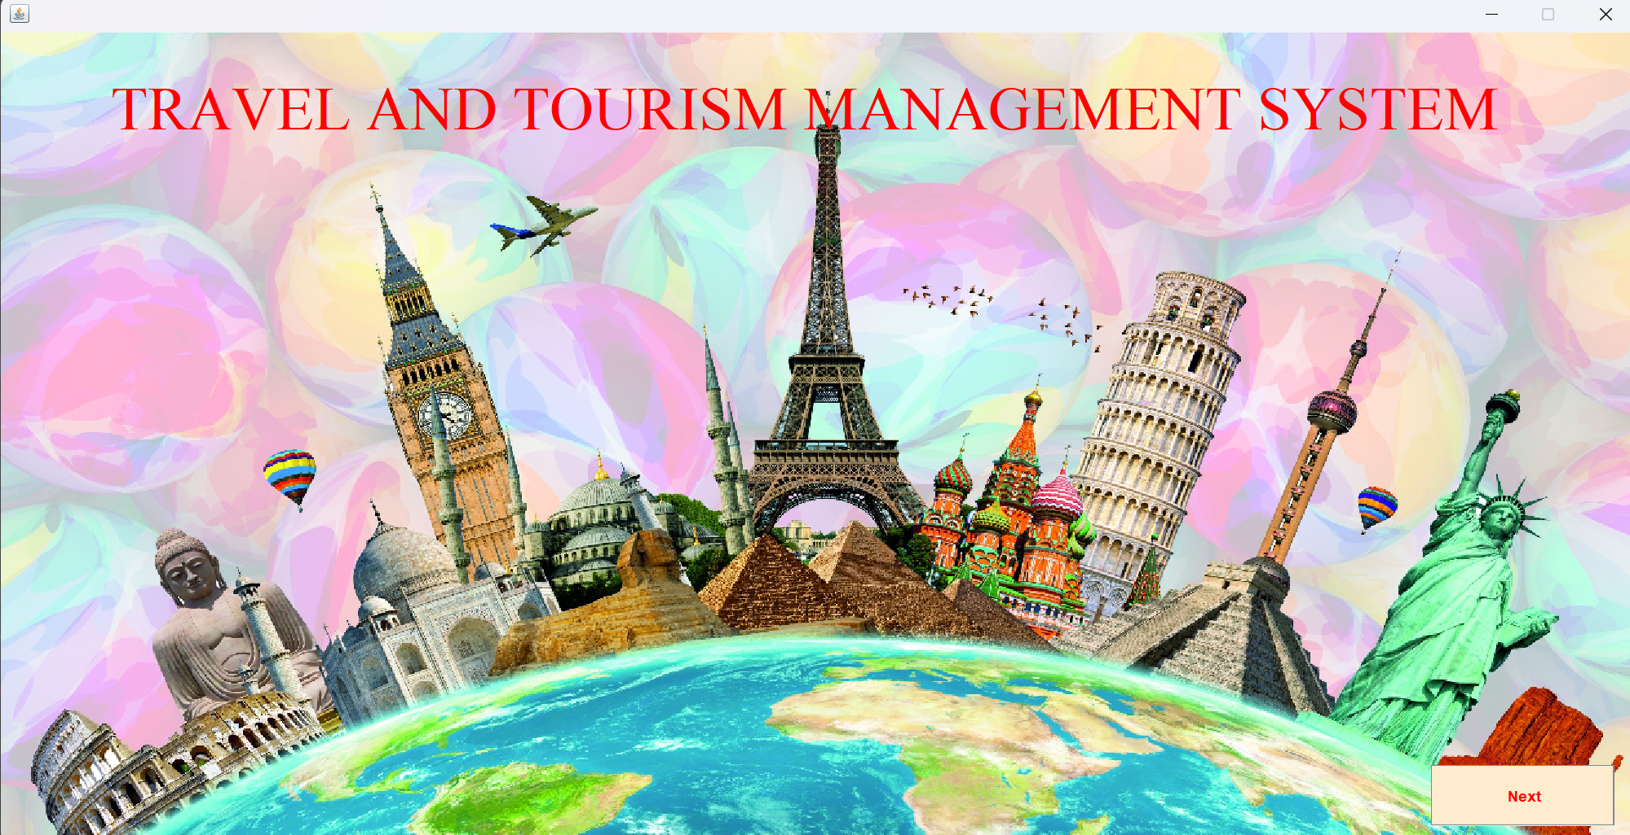

*Figure 1: Front page*

1. **Home Page:After login, users can access booking options.**

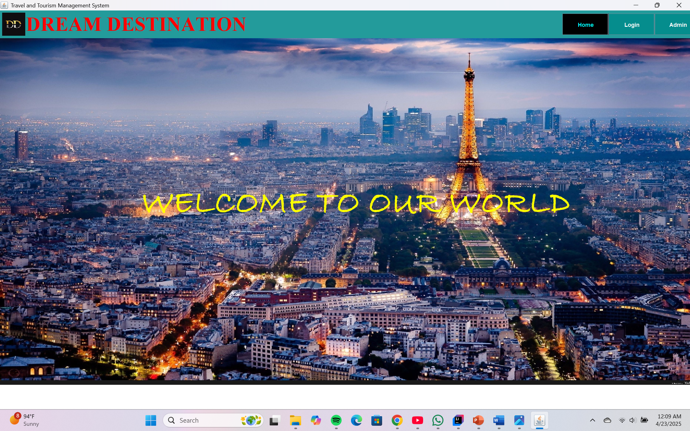

*Figure 2: Home page*

1. **Login/Admin Login Page: User and admin access portals.**

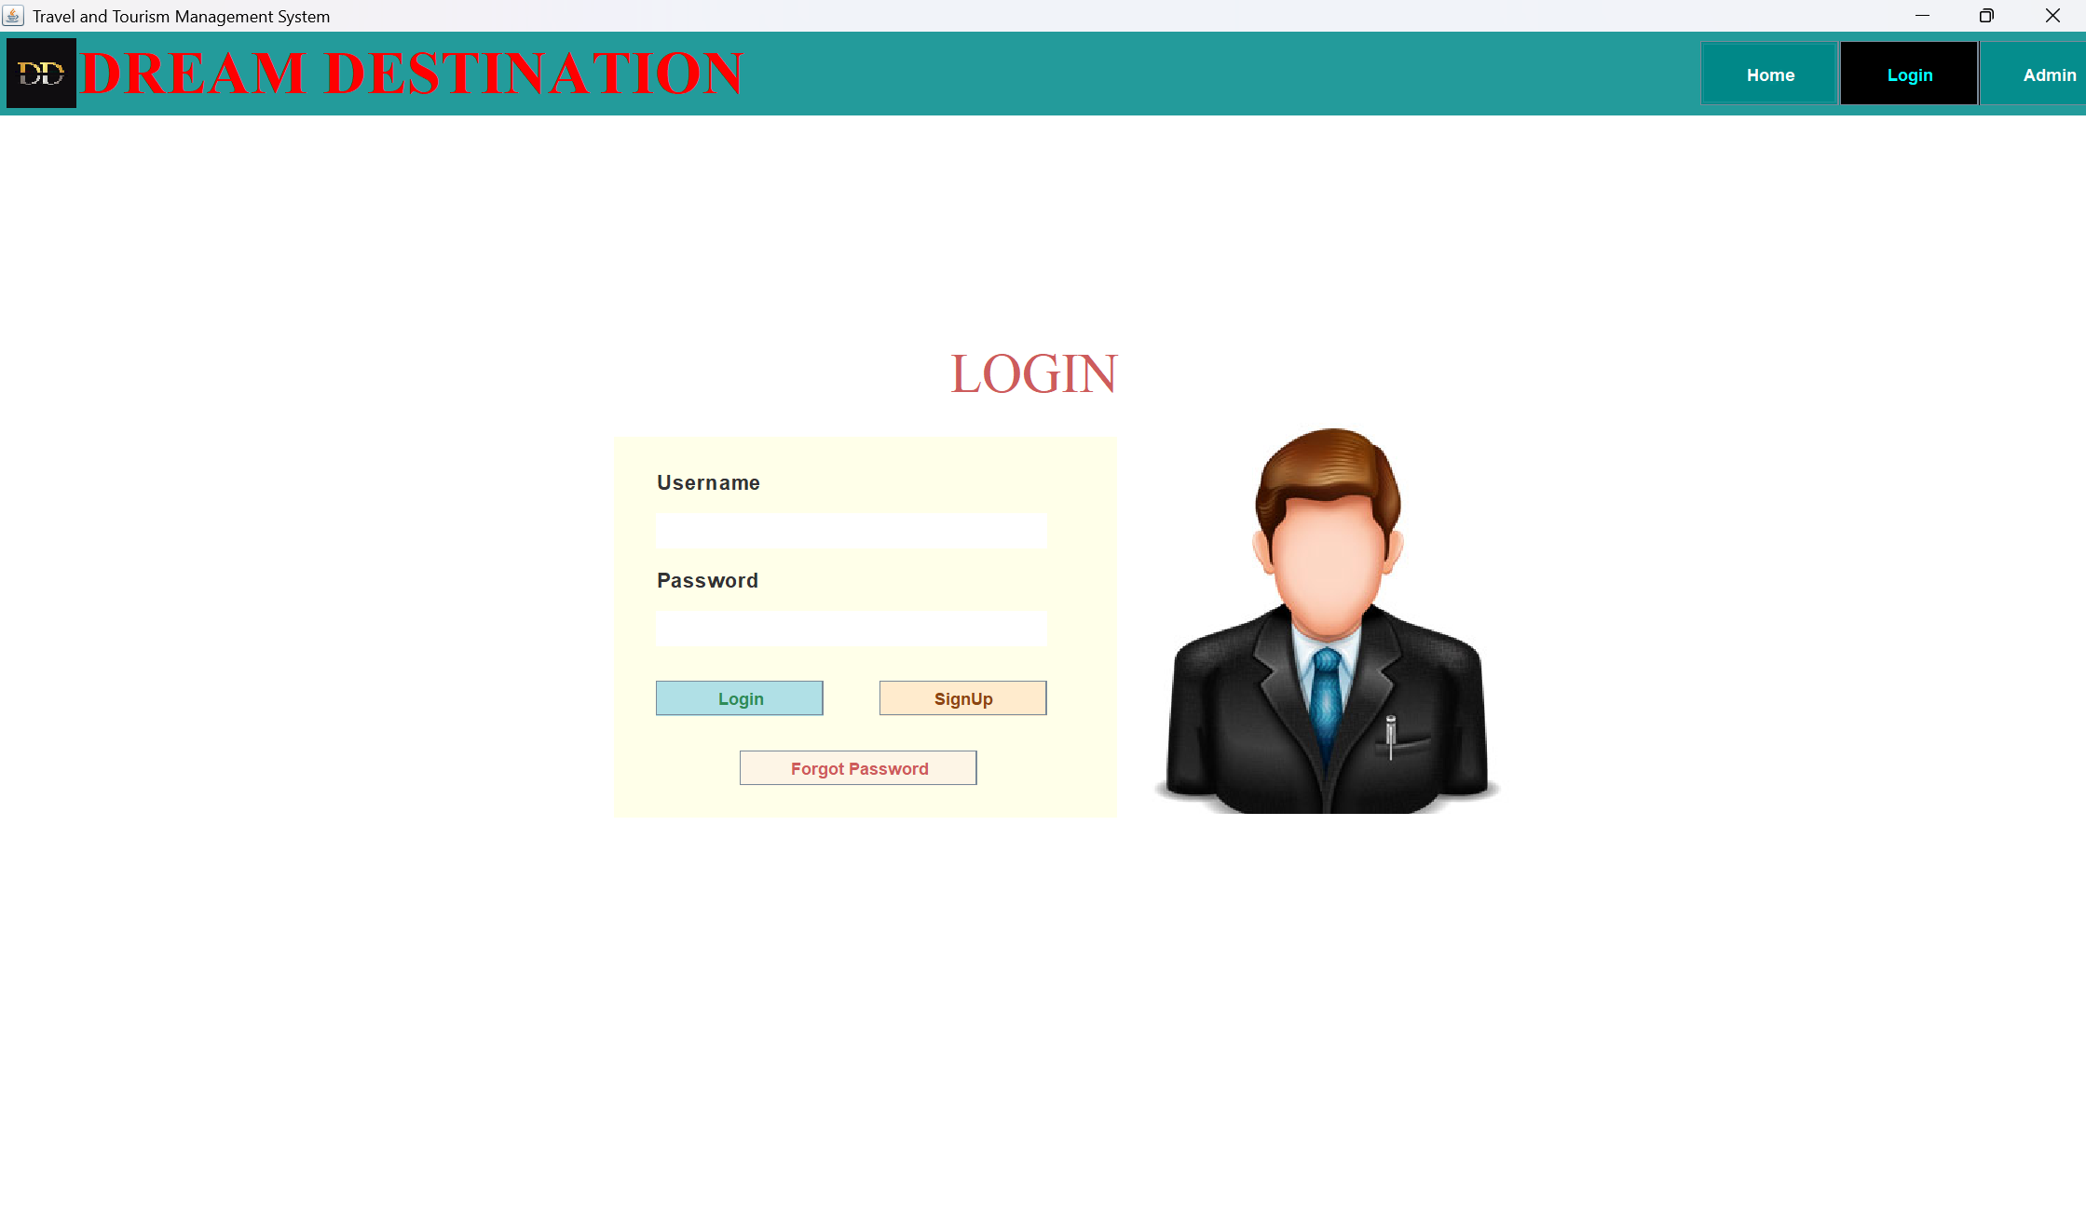

*Figure 3: Login page*

1. **Customer Home: Personalized user dashboard.**

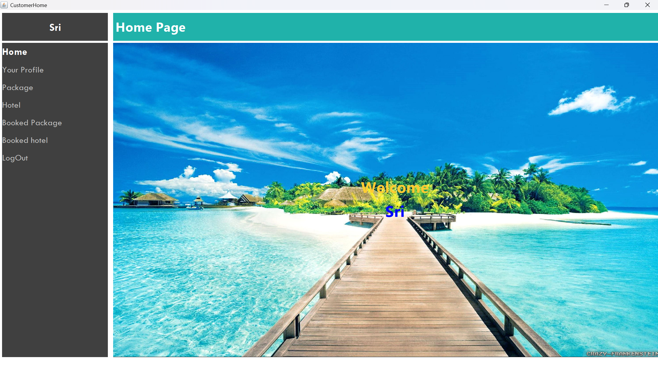

*Figure 4: Customer Home*

1. **Profile Panel:View or update profile details.**

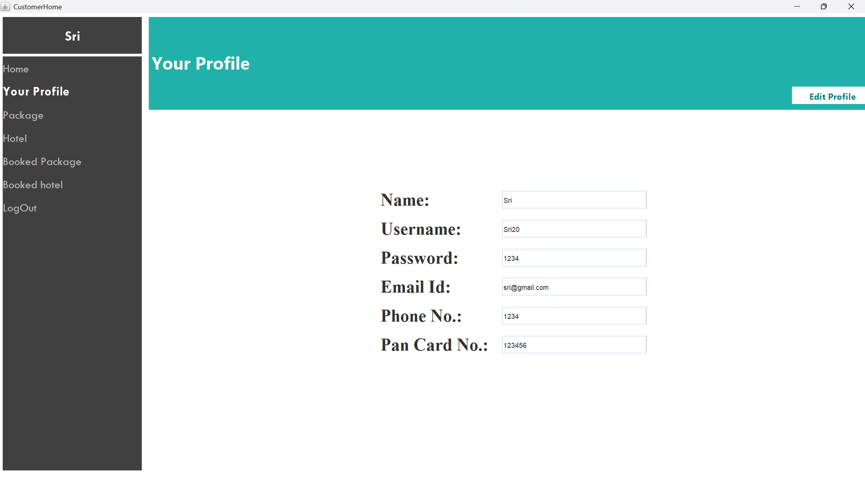

*Figure 5: Customer profile*

1. **View available Hotel/Package: Users can view packages/hotels**

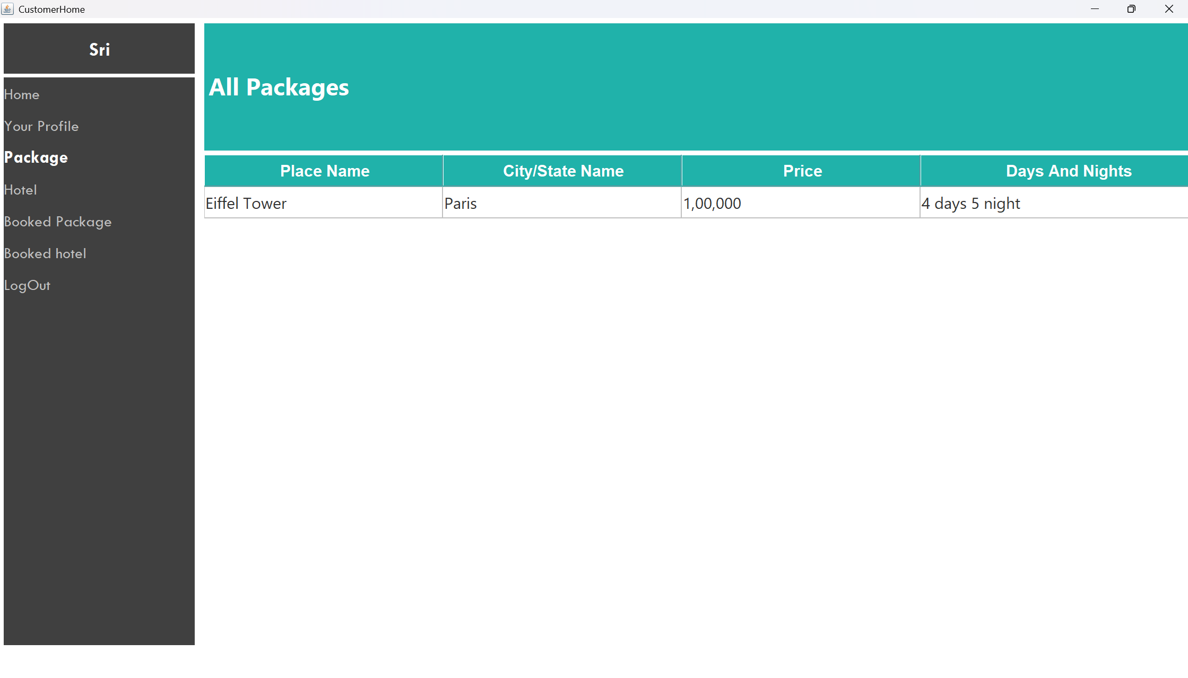

*Figure 6: View all packages*

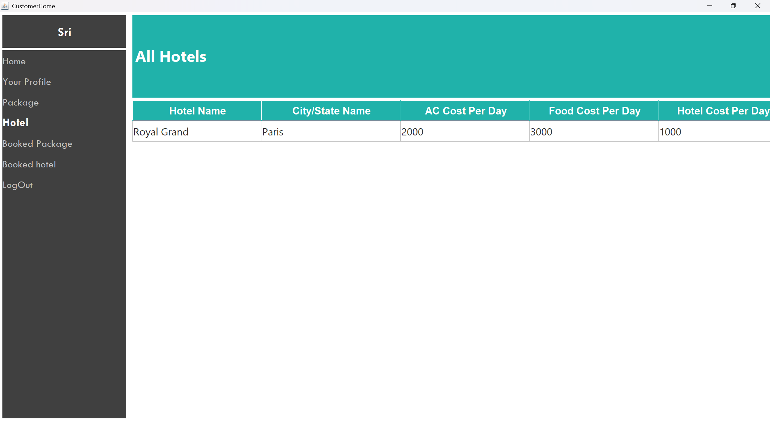

*Figure 7: View all hotels*

1. **Booked Hotel/Package Panel: Shows user bookings.**

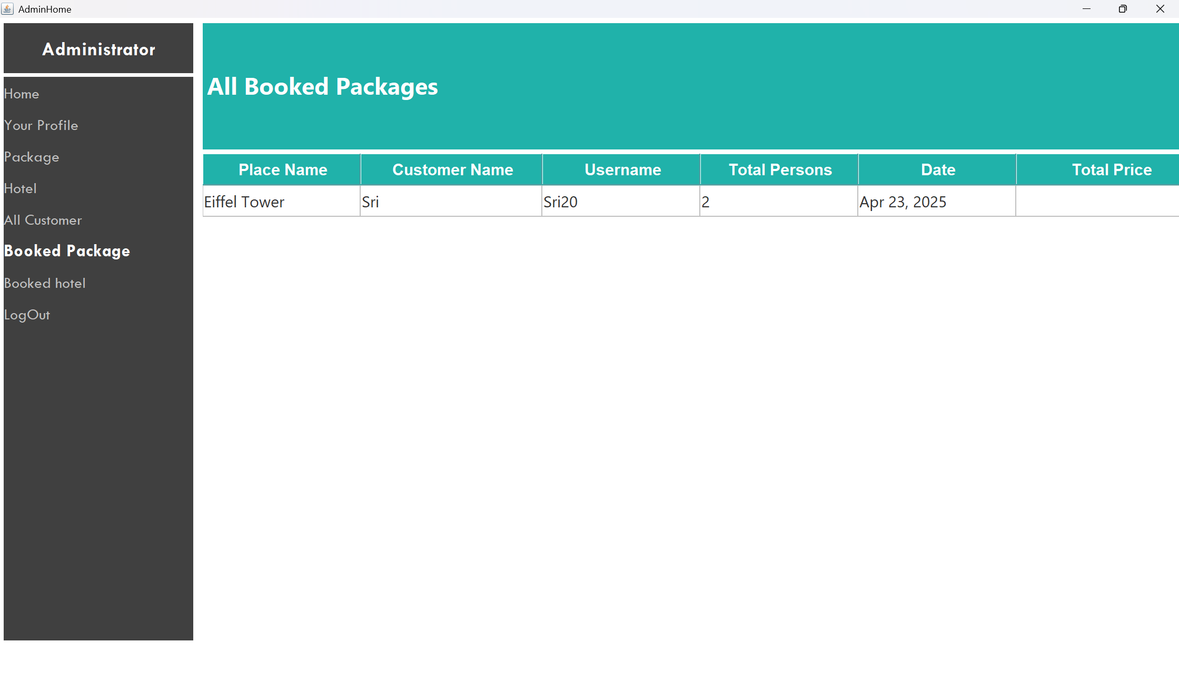

*Figure 8: Booked packages*

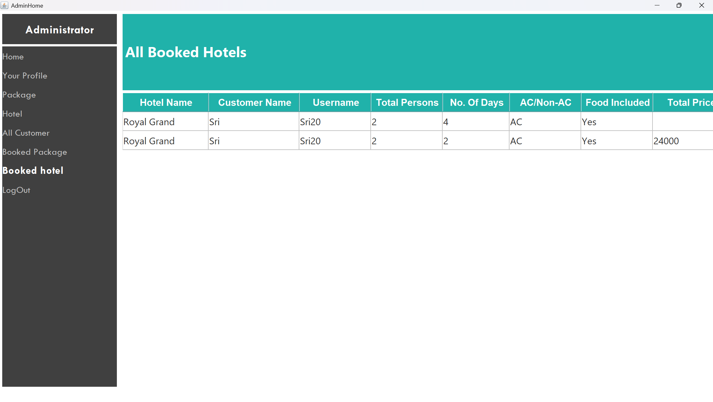

*Figure 9: Booked hotels*

1. **All Customer Panel: Admin view for all users.**

**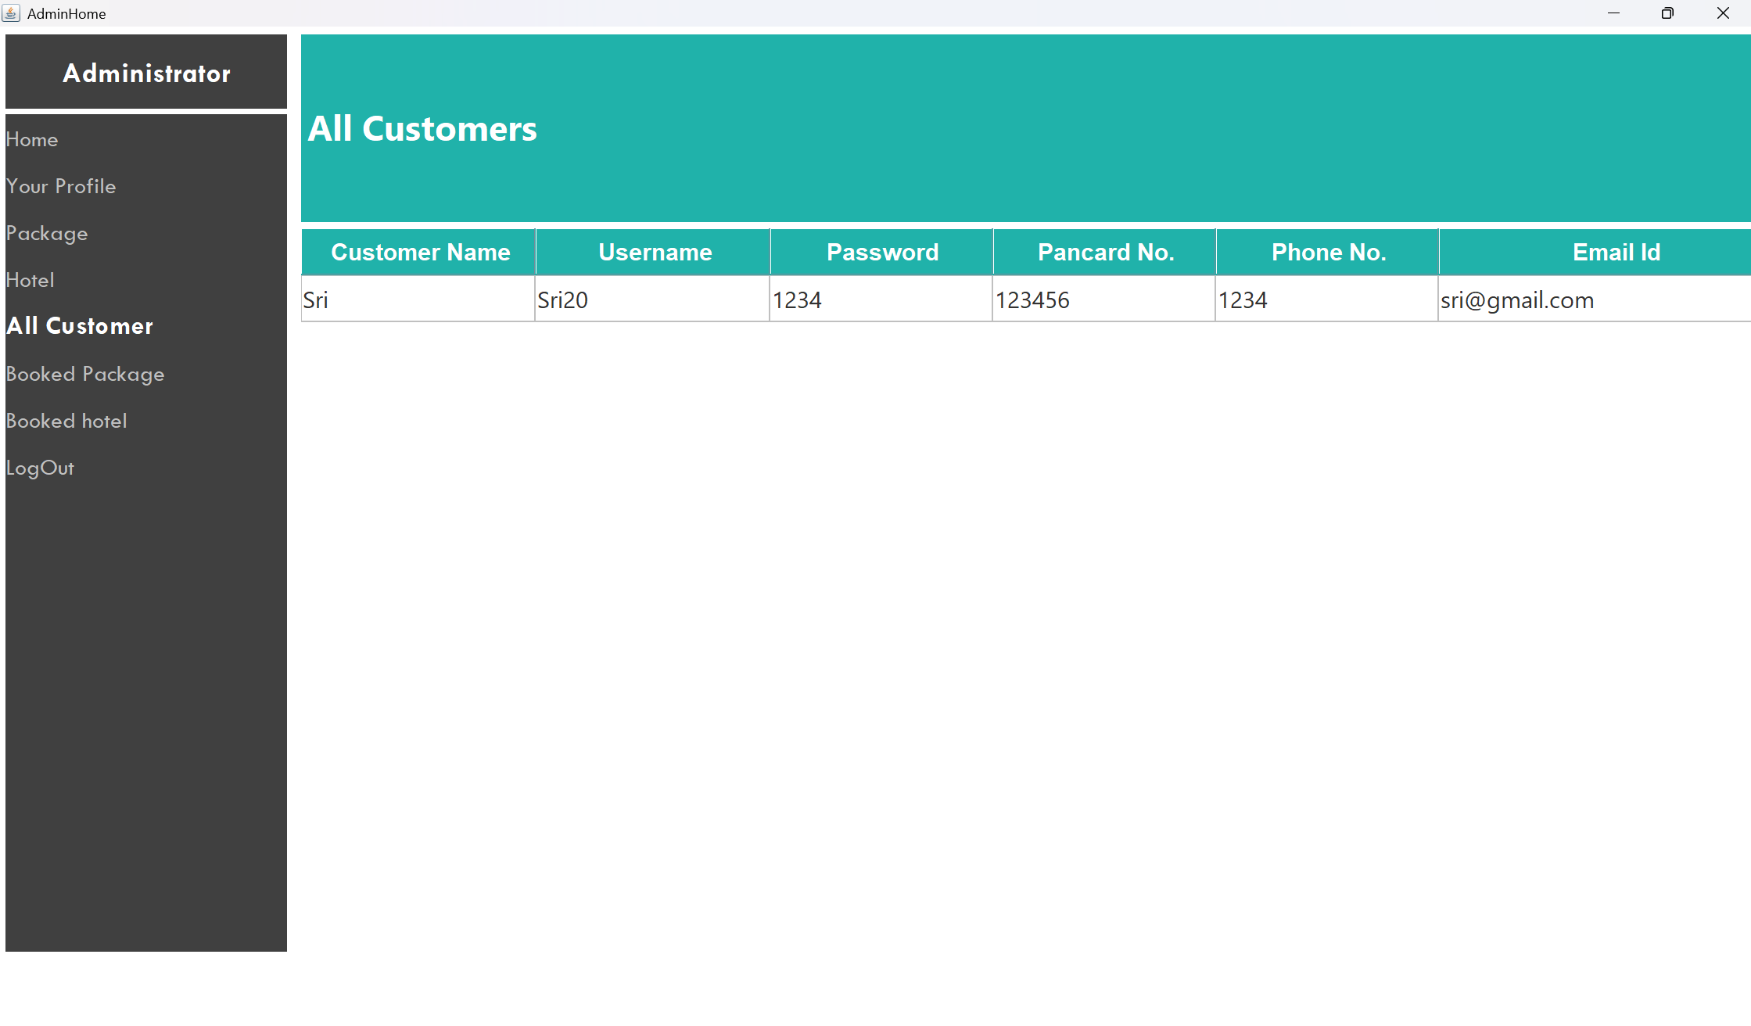***Figure 10: All Customers panel*

1. **Forgot Password: Retrieve and reset login credentials.**

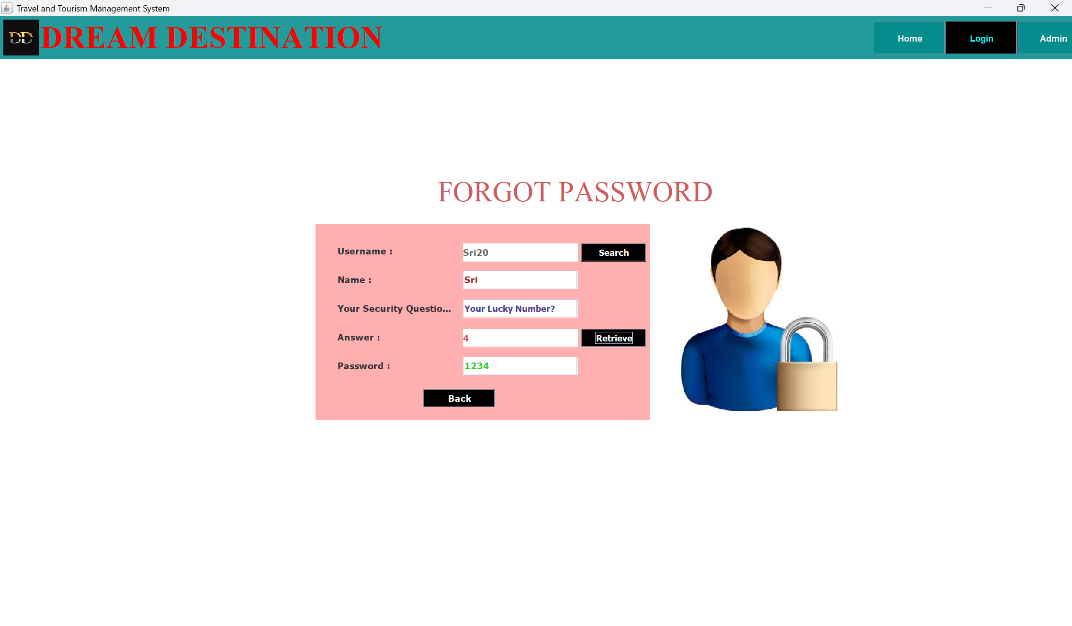

*Figure 11: Forgot password page*

**CONCLUSION**

The Travel and Tourism Management System successfully addresses the core needs of a travel agency by digitalizing its services. It enhances customer experience through an easy-to-use interface and empowers admins with robust management tools. Developed entirely in Java using Swing and JDBC, it demonstrates how desktop applications can be both powerful and user-friendly. The modular design and comprehensive functionality make it a scalable solution for any travel-based business.